# Exercises: JSF – Libraries, tags and templates

Problems for exercises and homework for the [“Java Web Development Basics” course @ SoftUni](https://softuni.bg/courses/java-web-development-basics). Submit your solutions on the **course page** of the **current instance**.

Let’s exercise a little the knowledge we’ve accumulated during the lesson for JSF.

# Fluffy Duffy Munchkin Cats v2(FDMC)

Remember Fluffy Duffy Munchkin Cats? If you do – good, if you don’t... Well FDMC is an application in which you register cats, with several properties. It has previous versions, but now is the time to create it more beatiful.

You will have to create a simple application which has several pages and 1 object entity. You will be provided with some resources like styles but you must implement the views, so they become similar to the pictures. Note that there are some requirements that you must check very carefully.

## Requirements

The application requirements are:

* JSF **Facelets** tags
* JSF **Basic** tags
* JSF **Convertor** tags
* JSF **Validator** tags
* JSF **DataTable**

## Data

This is the data layer of the application. There is 1 data object for you to implement.

### Cat

Create a Cat class, which holds the following properties:

* name – a **String,** must contain at least 2 characters, shouldn’t be longer than 10.
* breed – a **String,** must contain at least 5 characters, shouldn’t be longer than 20.
* color – a **String**.
* age – an Integer, must be between 1 and 31.
* gender – a **String**.
* price – a decimal value, must be at least 0.01.
* addedOn – a date without time.
* hasPassport – a boolean value.

NOTE: You must validate you cat fields everywhere it is possible, in other words – on front-end and back-end.

## Home Page

The home page must look like this

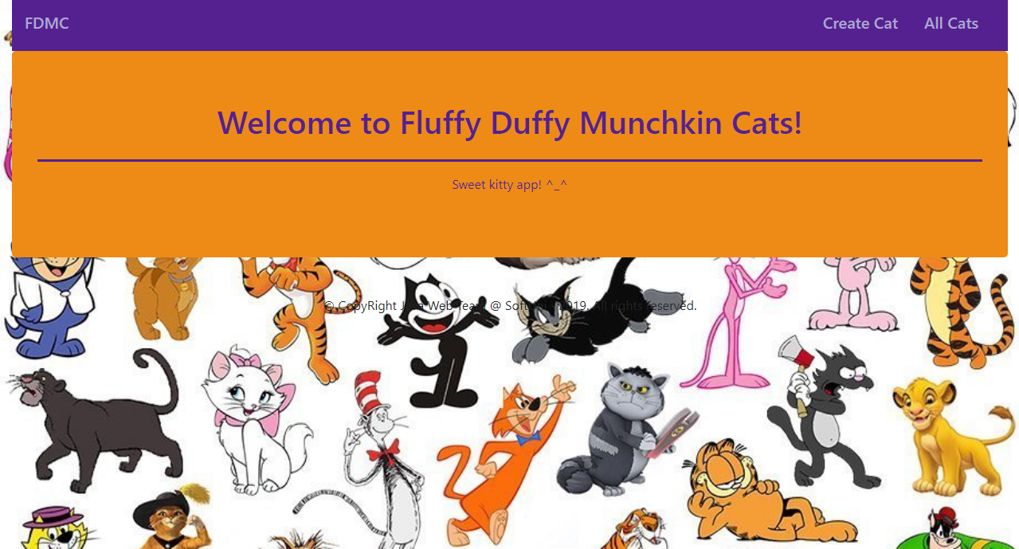

There are **2 links** on the navbar, which must lead to the following **jsf**:

Create Cat – “/jsf/cat-create.xhtml”

All Cats – “/jsf/all-cats.xhtml”

## Cat Create Page

Implement a **page**, with form, looking like this:

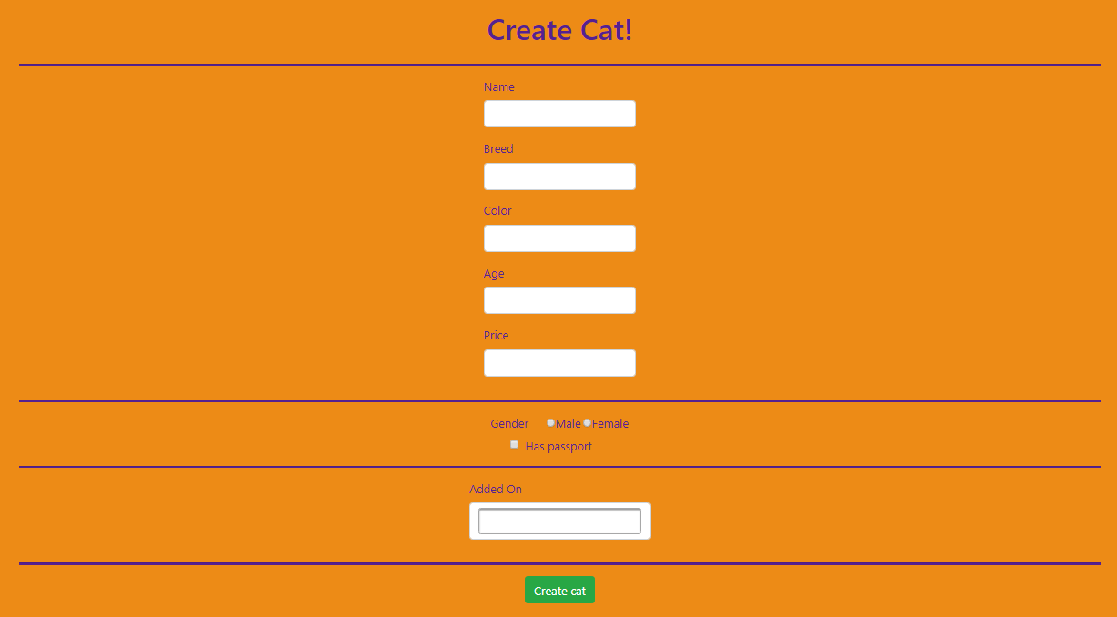

**NOTE**: For the field “Added On” you can use PrimeFaces calendar ☺

## All Cats Page

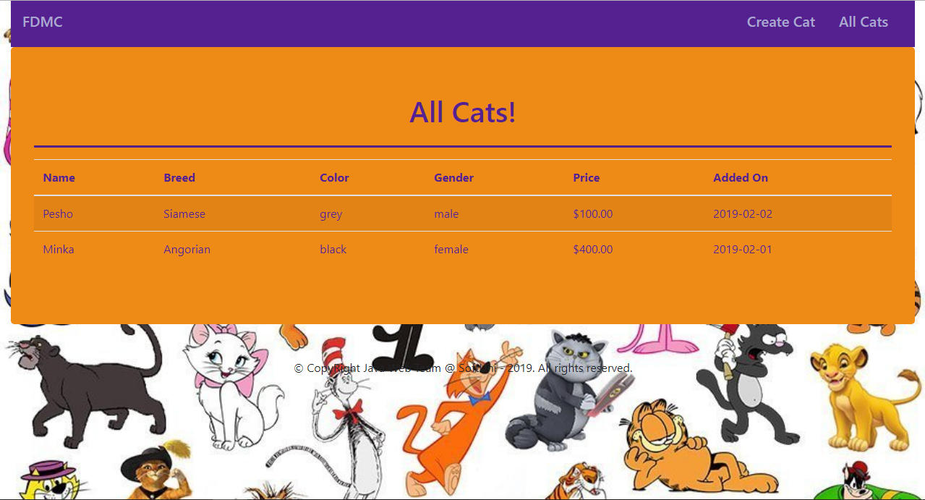

It must contain table with all cats.

## Bonus

On the all cats page you can create functionality that sorts the data in the table.